**Exploring Zomato: Country-wise Restaurant Distribution in India**

Understanding the Landscape of Restaurant Distribution



**Introduction** :

Welcome, everyone! Today, we embark on a journey through the rich culinary landscape of India, as depicted by Zomato, one of the leading food delivery and restaurant discovery platforms in the country.

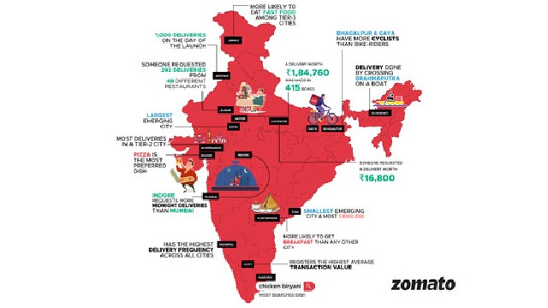

**About Zomato**

Before we delve into our visualization, let's briefly touch upon Zomato's significance in the Indian food industry. Founded in 2008, Zomato has revolutionized how Indians discover, order, and enjoy food, with millions of restaurants listed on its platform across various cities.

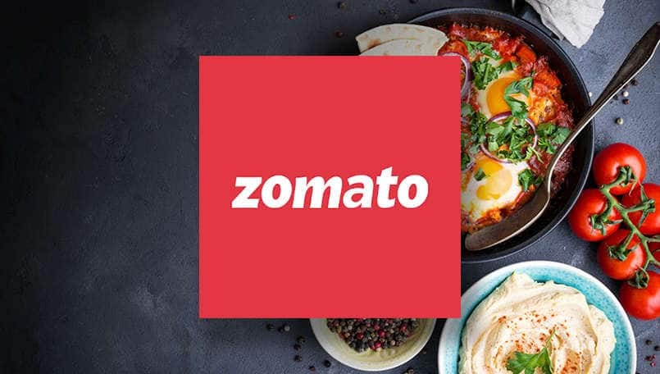

**Methodology**

To create our visualization, we gathered data from Zomato's extensive database. Using this data, we analyzed the distribution of restaurants across different states and union territories in India.



**Visualization - Country-wise Distribution**

Now, let's dive into our visualization. The following map illustrates the distribution of restaurants across India, categorized by states and union territories. Each region is color-coded based on the number of restaurants present.

Choropleth map of world showing restaurant distribution (image)

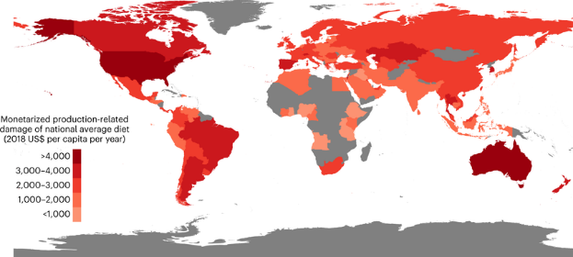

**Country wise count of** . **restaurant**

Our visualization reveals several interesting insights. Some countries, such as India and USA, boast a high concentration of restaurants, reflecting their vibrant food scenes. Meanwhile, other regions exhibit comparatively fewer restaurants, indicating potential opportunities for culinary expansion.

Chart depicting top states by restaurant count

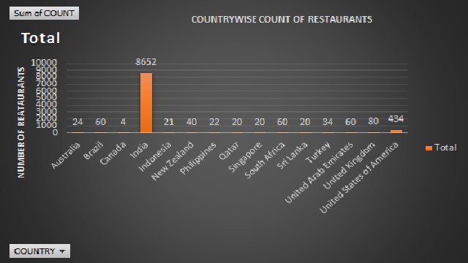

**YearWise number of restaurant opened**

In 2018 most no. of restaurant open

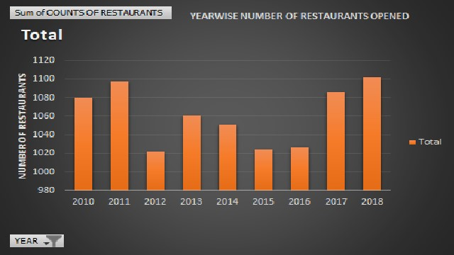

**Suggested countries rating**

Here’s a short rating of suggested countries for opening the most restaurants:

1. **United States**: High population density and diverse tastes.
2. **China**: Growing middle class and urbanization.
3. **India**: Large, youthful population with increasing dining out trends.
4. **Brazil**: Growing middle class and strong dining culture.
5. **Vietnam**: Rapid economic growth and tourism.
6. **Indonesia**: Large population and expanding economy.
7. **UAE**: High-income market and strong tourism.
8. **Mexico**: Large market with a dining-out culture.
9. **Thailand**: Popular tourist destination with a diverse food scene.
10. **Turkey**: Strategic location with a rich dining culture.

These countries offer strong potential for restaurant growth based on population, economic trends, and dining habits.

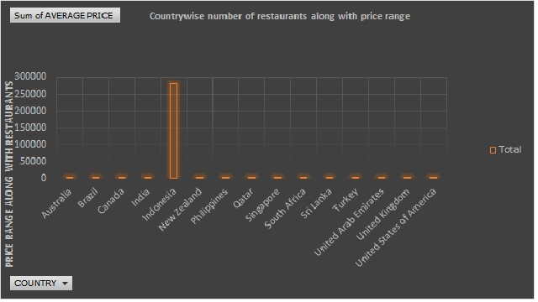

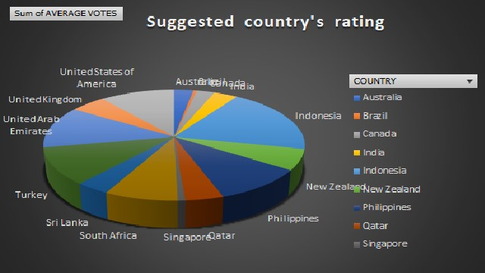

**Country wise average number of votes**

In which most number of restaurant should be opened

The best locations to open the most restaurants are:

1. **High Population Density Areas:** Major cities and growing suburbs with many potential customers.
2. **Tourist Destinations:** Cities and resort areas that attract a lot of tourists, ensuring a steady customer base.
3. **Emerging Markets:** Rapidly developing countries and second-tier cities with growing middle-class populations.
4. **Underserved Markets:** Neighborhoods with few dining options or high demand for specific cuisines.
5. **College and University Towns:** Areas with large student populations needing affordable dining choices.

Choosing locations with high demand, growing economies, or limited competition is key to success.

4o

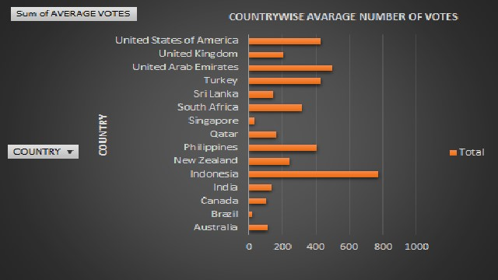

**Total**

Country which has sum of average price

The relationship between cuisine and prices is influenced by several factors:

1. **Type of Cuisine:** Less common or exotic cuisines can be more expensive due to unique ingredients and specialized preparation.
2. **Location:** Urban areas and regions where a cuisine is rare often have higher prices, while local or common cuisines may be cheaper.
3. **Ingredients:** High-quality, fresh, or imported ingredients typically increase the cost of dishes.
4. **Preparation and Presentation:** Dishes that require complex preparation or offer an elevated dining experience usually come at a higher price.
5. **Market Demand:** Popular or trendy cuisines can command higher prices due to increased demand.

Overall, cuisine prices vary based on the complexity, rarity, quality, and demand for the food.

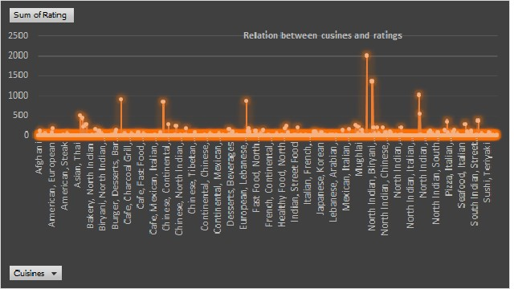

**Conclusion**

In conclusion, our visualization of country-wise restaurant distribution on Zomato offers a compelling glimpse into the dynamic culinary landscape of India. As the food industry continues to evolve, understanding these trends becomes increasingly essential for informed decision-making and innovation.

